Financial Lit Name: _______________________

______________ _____________

WS Assessment

Target 3:

STOCK and dividend

**I can:**

* Understand stock splits and Calculate the post-split outstanding shares
* Calculate the fractional value amount that a shareholder receives after a split
* Compute dividend income, yield for a given stock.

**Unit 1 Math Topics:**

* Fractions, decimals and percent
* Linear equation
* Literal equation
* Mean – Arithmetic average
* Percent increase, decrease
* Ratio and proportion
* Read, interpret and create bar and line graphs
* Simple moving average
* Spreadsheets and formulas

Debbie buys 400 shares of stock for $23 per share, and pays a 1% commission. She sells them six years later for $23.25 per share, and pays a $30 flat fee. Are her net proceeds positive or negative? Explain.

A stock split is a decision by a company's board of directors to increase the number of shares that are outstanding by issuing more shares to current shareholders. The primary motive is to make shares seem more affordable to small investors even though the underlying value of the company has not changed.

In a reverse stock split, the effect is just the opposite. The number of outstanding shares is reduced and the market price per share is increased. As the price per share increases, the investor perceives that the stock is worth more. This often happens to stocks known as penny stocks, whose value is less than $5 per share.

On December 4, John Deere Corporation (DE) instituted a 2-for-1 stock split. Before the split, the market share price was $87.68 per share and the corporation had 1.2 billion shares outstanding. What was the presplit market cap for John Deere? What was the post-split number of shares outstanding? What was the post-split market price per share?

In October, Johnson Controls, Inc instituted a 3-for-1 split. After the split, the price of one share was $39.24. What was the pre-split price per share?

In general, in any a-for-b split, you can apply the following formulas.

Post-split **number** of shares = $\frac{a}{b}$ × Pre-split **number** of shares

Post-split share **price** = $\frac{b}{a}$ × Pre-split share **price**

**EXAMPLE 4**

On October 15, Palm, Inc. instituted a 1-for-20 reverse stock split. Before the split, the market share price was $0.64 and there were 580,000,000 shares. What was the post-split share price and number of shares?

The previous examples had shares that could be split into whole-number amounts. In reality, this may not be the case. Often the split would create a **fractional part of a share**. In other words, there is less than one share remaining. When this happens, the corporation buys the fractional share at the current market price.

Steve owned 942 shares of Graham Corporation. On January 3, a 5-for-4 split was announced. The stock was selling at $56 per share before the split. How was Steve financially affected by the split?

Gabriella owned 1,045 shares of Hollow Corporation at a price of $62.79. The stock split 3-for-2. How was Gabriella financially affected by the split?

On June 19 California Pizza Kitchen, Inc. instituted a 3-for-2 split. At that time Krista owned 205 shares of that stock. The price per share was $33.99. After the split, Krista received a check for a fractional part of a share. What was the amount of that check?

Redo this problem on spreadsheet for stamp <http://bit.ly/30OscKz>

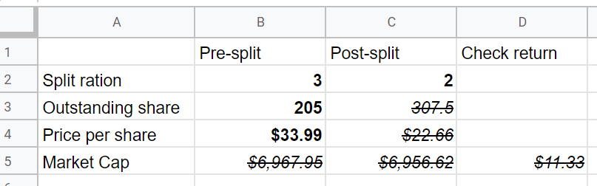

Do this problem by spreadsheet

On December 14, XTO Energy, Inc. executed a 5-for-4 split. At that time, Bill owned 325 shares of that stock. The price per share was $65.80. How was Bill financially affected by the split?

If you buy a stock and watch its price rise, it’s exciting, but your profit is only realized when you actually sell it. Keep in mind that capital gains and net proceeds cannot be computed and are not assured until the stock is actually sold. However, your stock portfolio can earn income before you sell

your shares. Remember, a shareholder is an owner of a corporation. As owners, shareholders are entitled to their portions of the corporation’s profit. Profit split among shareholders is called a **dividend**. Money received from dividends is **dividend income**.

Roberta is considering purchasing a common stock that pays an annual dividend of $2.13 per share. If she purchases 700 shares for $45.16 per share, what would her annual income be from dividends?

Monique owns x shares of stock. The quarterly dividend per share is y dollars. Express Monique’s annual dividend amount algebraically.

To find the **yield** of a stock, write the ratio of the annual dividend per share to the current price of the stock per share and convert to a percent. A yield can change even when a dividend amount does not because the price of the stock changes frequently.

Kristen owns common stock in Max’s Toy Den. The annual dividend is $1.40. The current price is $57.40 per share. What is the yield of the stock to the nearest tenth of a percent? (Ans: 2.4%)

The Black Oyster Corporation is going out of business. All of the corporate assets are being sold. The money raised will be split by the stockholders. Which stockholders, the common or preferred, receive money first? Hint: google

The Walt Disney Company paid a $0.35 annual dividend on a day it closed at a price of $33.86 per share.

a. What was the annual dividend for 500 shares?

b. What was the quarterly dividend for 500 shares?

c. What was the yield to the nearest tenth of a percent?

Redo this problem on spreadsheet for stamp <http://bit.ly/2ZIUuVe>

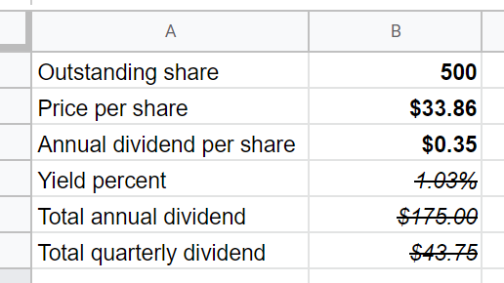

Do this on spreadsheet for stamp

The Zeescore Corporation pays an annual dividend of $2 per share. On Wednesday it closed at $61 per share with a net change of −0.85. The dividend remained at $2 for a year.

a. What was the yield on Wednesday?

b. At what price did Zeescore close on Tuesday?

c. What was the yield on Tuesday?

d. Tuesday’s net change was −1.96. At what price did Zeescore close on Monday?

e. What was Monday’s yield?

f. Look at the yields for Monday, Tuesday, and Wednesday. They are increasing. Explain why this increase is not “good news” to the investor who owns stock in Zeescore.

<http://bit.ly/2Pu8z9g>

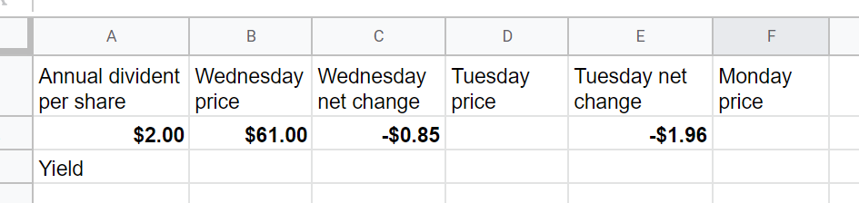

**Assessment Target 3**

**I can…** calculate a dividend, yield of stock and understand stock split

Stock in Happy’s Burger Chain was selling for $54.24 per share, and it was paying a $2.46 annual dividend. It underwent a 3-for-1 split.

What was the new price of one share after the split?

If you owned 200 shares before the split, how many shares did you own after the split?

Following the same pattern, what was the annual dividend per share after the split?

Setup this problem on spreadsheet for stamp:

Now you will google the current price per share of stock of your choice and change

change the split ratio, number of share and include check return value



The Revreg Corporation pays an annual dividend of $1.60 per share. On Friday it closed at $44 per share with a net change of +0.35. The dividend did not change.

a. What was the yield on Friday?

b. At what price did Revreg close on Thursday?

c. What was the yield at Thursday’s close?

d. Thursday’s net change was +1.22. At what price did Reverg close on Wednesday?

e. If the dividend was $1.60 on Wednesday, what was the yield at Wednesday’s close?

f. Look at the yields for Wednesday, Thursday, and Friday. They are decreasing. Explain why this decrease is not “bad news” to the investor who owns stock in Revreg.

Show me the spreadsheet for stamp.